SQL Server 2019 FineBuild Quick Start

Version 3.4.2

Ed Vassie
1-click installation and best-practice configuration for SQL Server
Document Control
  - Change History
FineBuild Change History is documented online. For details please see
http://sqlserverfinebuild.codeplex.com/wikipage?title=FineBuild%20Change%20History
  - Changes Forecast
None.
  - Related Documents
Title | Author | Description
SQL Server FineBuild Wiki | Ed Vassie | Main reference for SQL Server FineBuild  http://sqlserverfinebuild.codeplex.com/wikipage?title=Documentation
SQL Server FineBuild Reference | Ed Vassie | Supplemental reference for SQL Server FineBuild
  - License
FineBuild is distributed under the terms of the MS-PL License, for full details see http://sqlserverfinebuild.codeplex.com/wikipage?title=License%20and%20Acknowledgements.
Table of Contents

Document Control 2
i Change History 2
ii Changes Forecast 2
iii Related Documents 2
iv License 2
Table of Contents 2
1 Overview 3
1.1 Introduction 3
1.2 Purpose 3
2 Workstation Build Install 4
2.1 Preparation 4
2.2 Syntax and Options 4
2.3 Running the FineBuild Install 5
3 Next Steps 6

Overview

Introduction
The main objective of SQL FineBuild is to make it easy for anyone to produce a best-practice installation and configuration of SQL Server.
For experienced staff, SQL FineBuild will simplify the automated deployment of a site standard ‘Gold Build’. For inexperienced staff, it packages the expertise needed to install SQL Server complete with Service Packs, Cumulative Updates, and useful tools, all configured for optimum use.
FineBuild also abstracts most of the differences in the operating system and the SQL Server version and edition, resulting in a similar experience when installing SQL Server 2005 Express on Windows XP through to installing SQL Server 2019 on a Windows 2016 Core cluster. All this is designed to fulfil the FineBuild strapline of 1-click installation and best-practice configuration for SQL Server.
FineBuild consists of this Quick Start guide, a FineBuild Reference manual, a Wiki, and associated scripts. The scripts are pre-configured to provide a best practice configuration, and require minimal configuration for drive letters and account names before deployment. However, a flexible configuration file and script parameters allow significant changes to the build if required. Site-specific scripts can also be included in the build process without the need to change any of the supplied code.
FineBuild is free for internal use by the organisation downloading FineBuild (including use in Production) and for personal use under the terms of the MS-PL License. Anything that can be described as commercial exploitation of FineBuild (e.g. selling FineBuild or FineBuild support services) requires separate licensing which can be obtained from the FineBuild author.
Even though there is no charge for using FineBuild, please donate whatever FineBuild is worth to you as all money goes direct to charity. Tearfund is one of the UK’s largest disaster relief and community development charities, and donations can be made direct to tearfund.org or via the link on the FineBuild site. Authors of some of the community tools also have donation links, so if you use that tool then please pay what it is worth to you.
The SQL FineBuild process describes four standard builds of SQL Server 2019 that address various requirements. These builds are described more fully at
http://sqlserverfinebuild.codeplex.com/wikipage?title=FineBuild%20Standard%20Builds.
- Default server build
- Named Instance server build
- Workstation build
- Client Tools only build

Purpose
The purpose of this document is to help the first-time user of SQL Server FineBuild to get the FineBuild process running.
The best way to understand what FineBuild does is to perform a Workstation install on to a spare server or desktop machine and compare the results with the SQL Server FineBuild Reference manual. After this first install, it will be more obvious what attributes in the configuration file need changing to reflect site standards.
FineBuild is designed to work with all editions of SQL Server 2019 on Windows server and client operating systems from Windows 10 onwards. It can be delivered either by running FineBuild manually, or by a distribution tool such as Altiris. To obtain the best performance on Windows, SQL Server should be installed on Windows 2016.

Workstation Build Install

Preparation
The install process you should use depends on the edition of SQL Server you want to install.
At the date of publication, the only available version of SQL Server 2019 was CTP2. For this edition you should use the SQLFineWorkstation file to install SQL Server. You will also need to prepare the install media as described in
http://sqlserverfinebuild.codeplex.com/wikipage?title=SQL%202019%20Media%20Preparation
The following restrictions apply to installing SQL Server 2019 with the current version of SQL FineBuild:
- SSIS Scaleout is not supported with the current version of SQL FineBuild.

Syntax and Options
If you are installing SQL 2019 Express Edition, you should use the SQLFineExpress.bat file as shown below:
If you are installing a server edition of SQL 2019 you should use the SQLFineWorkstation.bat file as shown below:
REM Copyright FineBuild Team © 2009 - 2015. Distributed under Ms-Pl License
REM
CALL "SQLFineBuild.bat" %* /Type:Workstation /IAcceptLicenseTerms ^
/Edition:Express ^
/SAPWD:"UseAL0ngPa55phrase!" /GroupDBA:"GBGGDBAS01" /GroupDBANonSA:"" ^
/VolProg:E
- The values in bold black must be supplied as shown
REM Copyright FineBuild Team © 2012 - 2015. Distributed under Ms-Pl License
REM
CALL "SqlFineBuild.bat" %* /Type:Workstation /IAcceptLicenseTerms ^
/SAPWD:"UseAL0ngPa55phrase!" /GroupDBA:”GBGGDBAS01” /GroupDBANonSA:”GBGGDBAN01” ^
/VolProg:E
- The values in bold purple must be supplied, but must contain the values required for your site.
The value for /GroupDBA: parameter should be the name of the Windows group containing DBA Accounts that need SQL Server Sysadmin access. This parameter can be removed if you do not have such a group.
The value for /GroupDBANonSA: parameter should be the name of the Windows group containing DBA Accounts that do not need SQL Server Sysadmin access. This parameter can be removed if you do not have such a group.
- The value in green is optional.
If site standards require that applications are not installed on to the System drive, use a /VolProg: parameter to specify the drive to hold the SQL Server program files, otherwise remove this parameter..
- The parameter /IAcceptLicenceTerms is required for each FineBuild install.
The use of this parameter means you accept the license conditions of FineBuild and the license conditions of all products installed by FineBuild.
Prior to using FineBuild you are advised to review the license conditions of all products that will be installed, and if you do not agree with any license condition you should not install the relevant product.
- If you are installing SQL 2019 Express Edition, it is recommended that SQL Express with Advanced Services is installed.

Running the FineBuild Install
All install activity should be done when logged on using an account with local Administrator authority.
- Navigate to the install media location using a URL. SQL FineBuild can be run directly from the software repository on the network.
- Navigate to the FineBuild folder (SQL2019\FineBuild)
Right-click on CmdHere.bat and select Run as administrator. This will create a temporary drive map to the network location.
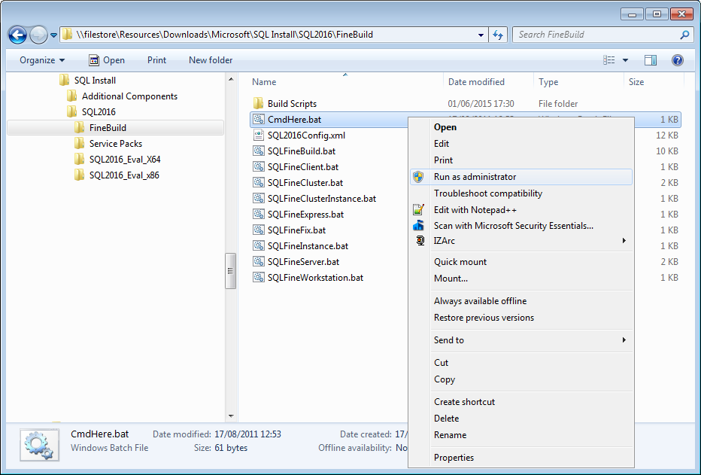
- Type the relevant command to start the install process. The SqlFineBuild script is called to run the standard setup.exe program but with parameters customised for the Workstation Build.
For SQL 2019 Express Edition, use the following command:
SqlFineExpress
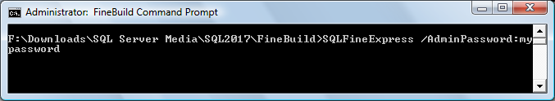
For a server edition of SQL 2019, use the following command:
SqlFineWorkstation
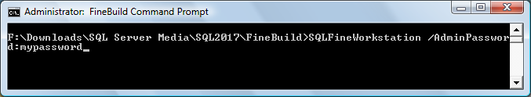
- The value of the /AdminPassword: parameter should be the password of the person running SQL FineBuild. This will allow FineBuild to automatically log on whenever a reboot is required during the install process.
- If you want to see what parameter options have been set without actually running the SQL Server install, add the following parameter to the command above:
/ReportOnly
- If any part of the FineBuild process fails, refer to the Troubleshooting section in the Wiki at http://sqlserverfinebuild.codeplex.com/wikipage?title=FineBuild Troubleshooting
- The SQL Server install is divided into two portions. The first portion installs pre-requisite software, and the second portion installs SQL Server 2019. Depending on the components installed and the operating system, a reboot may take place before the main SQL Server install is started.
After the reboot has completed, log on with the same account as used for the pre-requisites and the install will resume automatically. It is not unusual for this stage to take 40 minutes.
- The next stage is designed to apply SP and CU maintenance. This stage can also take around 40 minutes.
- After the SQL maintenance has been applied, the community tools are installed.
- The Configuration stage applies best practices to the SQL Server instance.
- The final stage prepares the SQL Server client tools for optimum use, and sets some Windows menu options.
- Reboot the server and explore the FineBuild Workstation Build results.
It is best to have a printed copy of the SQL Server FineBuild Reference manual and have access to the FineBuild Wiki while you explore your first FineBuild.
The SQL Server FineBuild Reference manual is a large document of about 60 pages. When printing it, try to conserve paper by using duplex mode, or by specifying that 2 or 4 pages should be printed on one sheet of paper.

Next Steps
It is recommended that you obtain a guest server and try out the other standard FineBuild installs. This will help you understand more about how FineBuild works, and how it can be used in your organisation. The standard builds are documented online at
http://sqlserverfinebuild.codeplex.com/wikipage?title=FineBuild Standard Builds.
In particular you should look at;
- Review the parameters available to SQL FineBuild and the syntax requirements. See https://sqlserverfinebuild.codeplex.com/wikipage?title=FineBuild%20Parameter%20Inventory.
- Identify configuration changes needed so that FineBuild complies with your site standards. See http://sqlserverfinebuild.codeplex.com/wikipage?title=FineBuild%20Parameter%Inventory to see how these could be implemented in SQL FineBuild.
- Enhancements to your site standards to take advantage of additional features in FineBuild.
When you have gained some experience in using FineBuild, it will be possible to plan how to use FineBuild for all your SQL Server installs. For more details see
http://sqlserverfinebuild.codeplex.com/wikipage?title=%20Large%20Scale%20Deployment%20Using%20SQL%20FineBuild.

END OF DOCUMENT

